University of Wah
Department of Computer Science

Submit to:

Ms. Wasifa Kanwal

Submit by:

Muhammad Talha

Course:

Information and Security_Lab - CS-251L

Reg No:

UW-24-CS-BS-101

Section:

BS-CS-3rd-B

Original Code

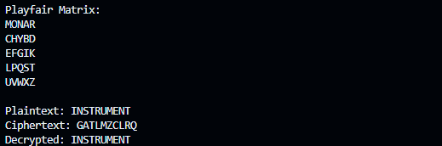

Task Pages
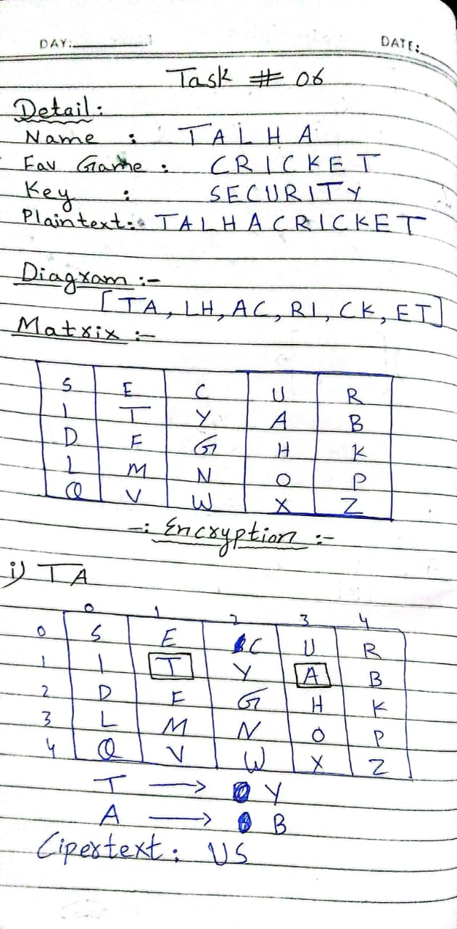
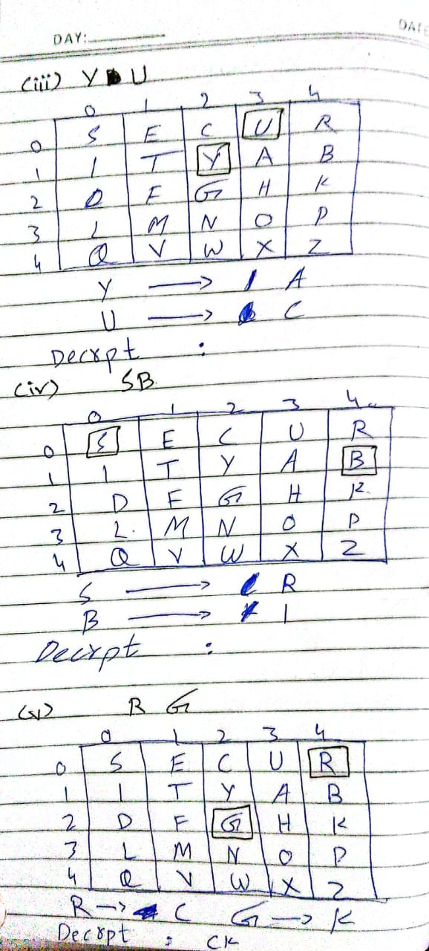
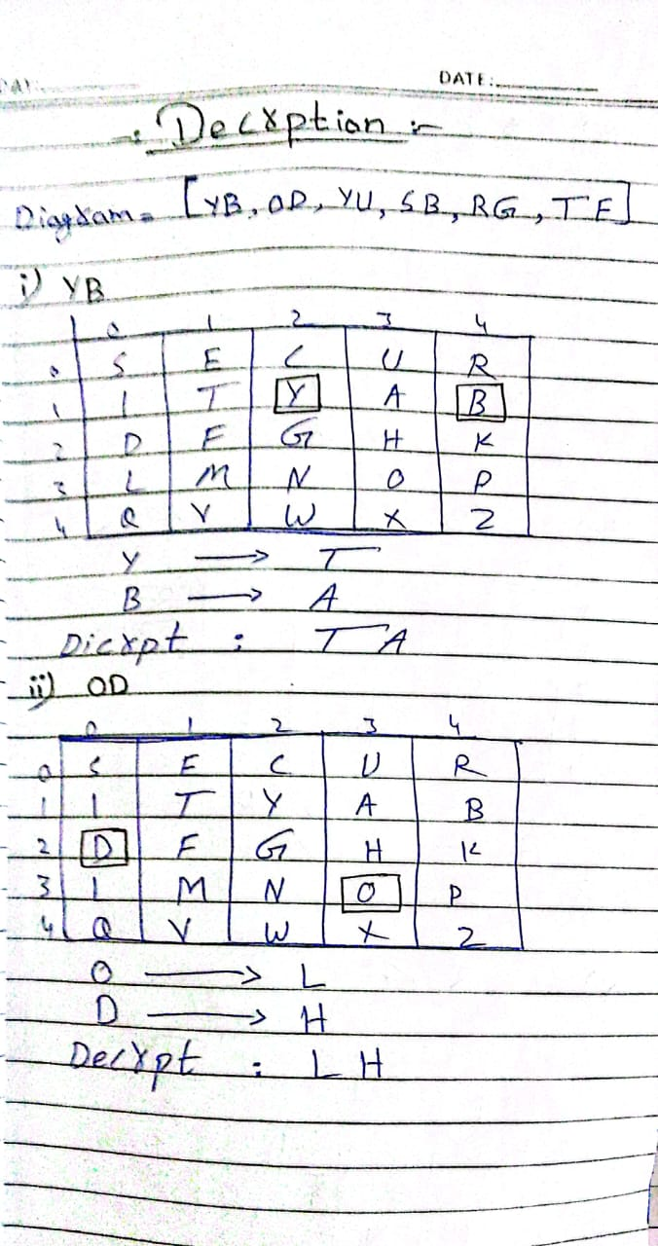
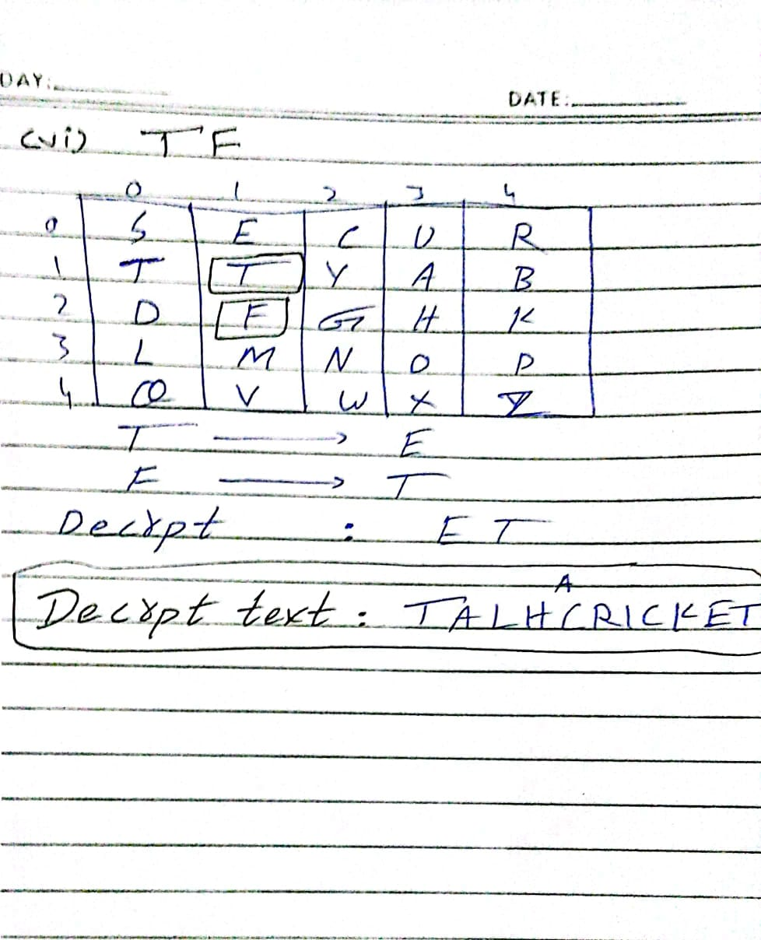

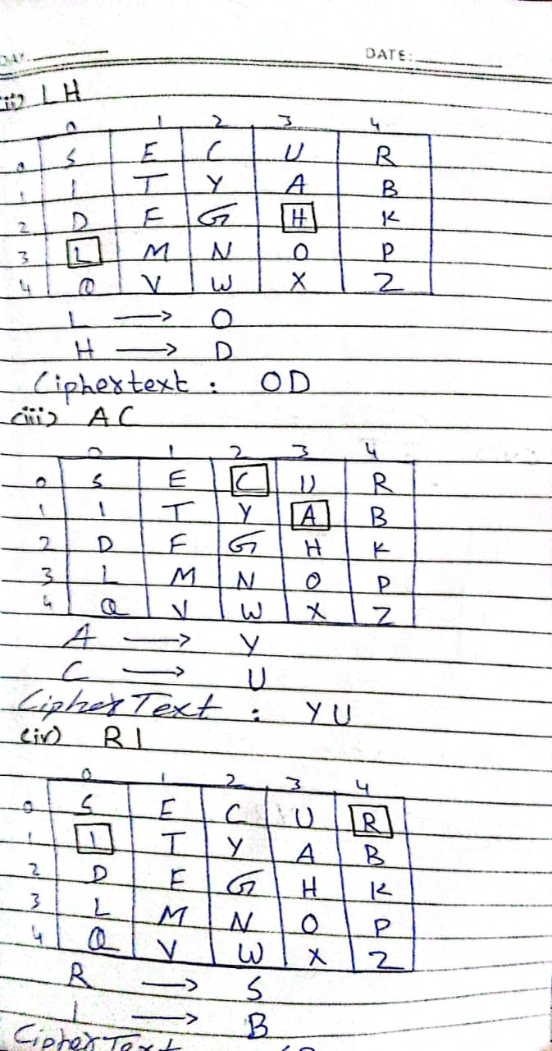
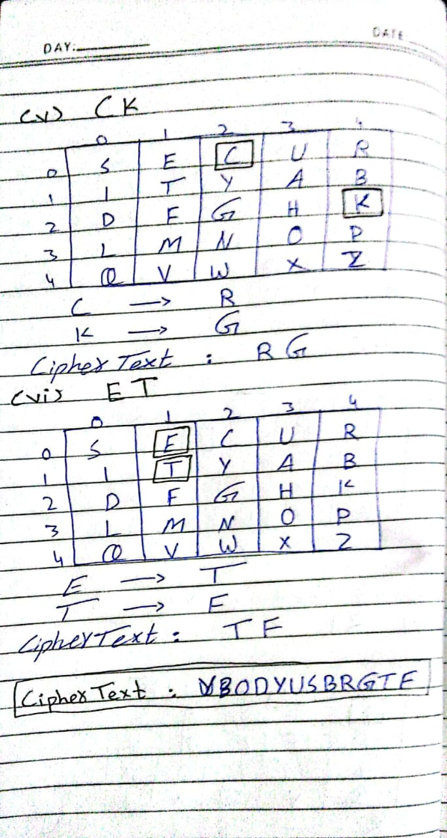
Testing Code

